Y1Q4W11

Namaan

Ask: Do you know anyone from another country?
Ask: Have you ever noticed that they do things differently than your family? Do they speak differently or eat differently?
Listen: To some different customs from other countries.

Say: People notice when other people are different, today we are learning about a little girl who was different.

Bible Story DVD

Ask: If the maid had not done her work well, do you think that her masters would have listened to her?
Ask: What is a witness?

Sing Songs

Return to tables
Memory Verse: Fill in the blanks and then say the memory verse on the colouring page.

Scrapbooks
- Choose a cardboard
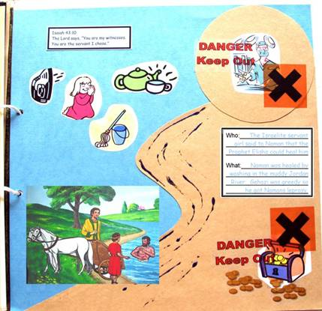
- Stick on Photo, Bible verse, Who/What Card and stickers.

Discuss the following depending on age, interest and time:
Discuss how people expect Christians to act?
What things make a good or bad witness?
Are there things that you notice about your neighbours or friends that you think are good or bad?
Are there things that you or your family does that makes a good or bad impression on your neighbours?
Do people know that you go to Church or that you are a Christian?
Do you think people would want learn more about Jesus by watching you?

Application
Ask: Do people know that you go to Church?
Ask: Do you think you act the way people who are Christians should act?
Ask: Do you think you are a good witness for Jesus?
Do: Hand out the survey – mark on each line where you think you are.
Say: Circle the items you need to work on.

Say: No one is perfect, and because of sin, no one will be perfect. But with God's help we can become better.

Finish with prayer. Pray that God will help each person to know what to do to become a better person and a better witness.

